Assignment 4

Ans.01

There are many key features that enhance the web

development :

1. New semantic elements: It introduced many semantic elements like <header> ,<footer> , <nav> ,<article> , <section> , <aside> ,etc.
2. Audio and Video: It also support audio and video by using <audio> , <video> element .
3. Canvas: The <canvas> element allows developer to draw manipulate graphics , animation , and interactive content , directly within the browser using javascript .
4. SVG support : It also support Scalable Vector Graphics (SVG).
5. Form improvements : It introduced new input type like ‘email’ , ‘url’ , ‘date’ , ‘number’ and ‘range’ . it also introduced ‘placeholder’ attribute for form field .

Ans.02

HTML entities are special codes used to represent reserved characters and symbols in HTML document . Here are five commonly used HTML entities

1. ‘&lt;’ - Less than sign (<):
2. ‘&gt;’ - Greater than sign (>):
3. ‘&amp;’ - Ampersand (&):
4. ‘&quot;’ - Double quotation mark (“):
5. ‘&apos;’ - Single quotation mark (‘):

Ans.03

Accessibility is the practice of making our websites usable by as many people as possible . May be some peoples using mobile devices , or those with slow network connections. We should giving them equal opportunities , no matter what their ability or circumstances .

We are all human , and therefore have the same human rights.

Building accessible sites benefits for everyone :

* Semantic HTML , which improves accessible , also improves SEO , making your site more findable .
* Caring about accessibility demonstrates good ethics and morals , which improves your image .
* Other good practices that improve accessibility also make your site more usable by other groups , such as mobile phone user or those on low network speed . In fact, everyone can benefit from many such improvements.

Ans.04

Three ways which help us to improve the accessibility of HTML are :

1. SEMANTIC HTML : Always use correct HTML elements for their correct purpose as much as possible.
2. HEADINGS : Always defined heading with <h1> to <h6>. It is important to use headings to show the document structure and the relationship between different sections.
3. DECLARE THE LANGUAGE : You should always include the lang attribute inside the <html> tag , to declare the language of the web page .

Ans.05

<!DOCTYPE html>

<html lang="en">

<head>

<meta charset="UTF-8">

<meta name="viewport" content="width=device-width, initial-scale=1.0">

<title>Features of HTML-5</title>

</head>

<body>

<header><h1>Welcome to features of HTML </h1></header>

<main>

<section>

<h2>1. Semantic Elements </h2>

<p>HTML5 introduced a set of semantic elements that provide more meaningful structure that help the developer to design and create more attarctive website , improving accessibility and SEO. Some key semantic tags include : </p>

<ul>

<li><code>&lt;header&gt;</code>: Defines a container for introductory content </li>

<li><code>&lt;section&gt;</code>: Represents a standalone section of content within a document</li>

<li><code>&lt;article&gt;</code>: Defines an independent,self-contained piece of contain, like a blog post or news article</li>

<li><code>&lt;footer&gt;</code>: Represents the footer of a section or a page , typically containing copyright and contact details.</li>

</ul>

</section>

<section>

<h2>2. Audio and Video Support</h2>

<p>HTML5 introduced native support for embedding audio and video content without the need for third-party like Flash. You can use the <code>&lt;audio&gt;</code> and <code>&lt;video&gt;</code>elements:</p>

<ul>

<li><code>&lt;audio&gt;</code>: Embeds audio content with controls for play, pause and volume. </li>

<li><code>&lt;video&gt;</code>: Embeds video content with playback controls , allowing you to include videos directly in your web pages. </li>

</ul>

</section>

<section>

<h2>3. Local Storage </h2>

<p>HTML5 introduced <strong>local storage </strong>, a client-side storage mechanism that allows web applications to store data locally in a user's browser. This feature enables: </p>

<ul>

<li>Persistent storage of data even after the user closes the browser. </li>

<li>Easy access to stored data using Javascript.</li>

<li>The ability to store key-value pairs of data for various purposes, such as user preferences and cached content.</li>

</ul>

</section>

</main>

<footer>

<p>&copy: 2023 HTML5 Features Showcase</p>

</footer>

</body>

</html>

Output:

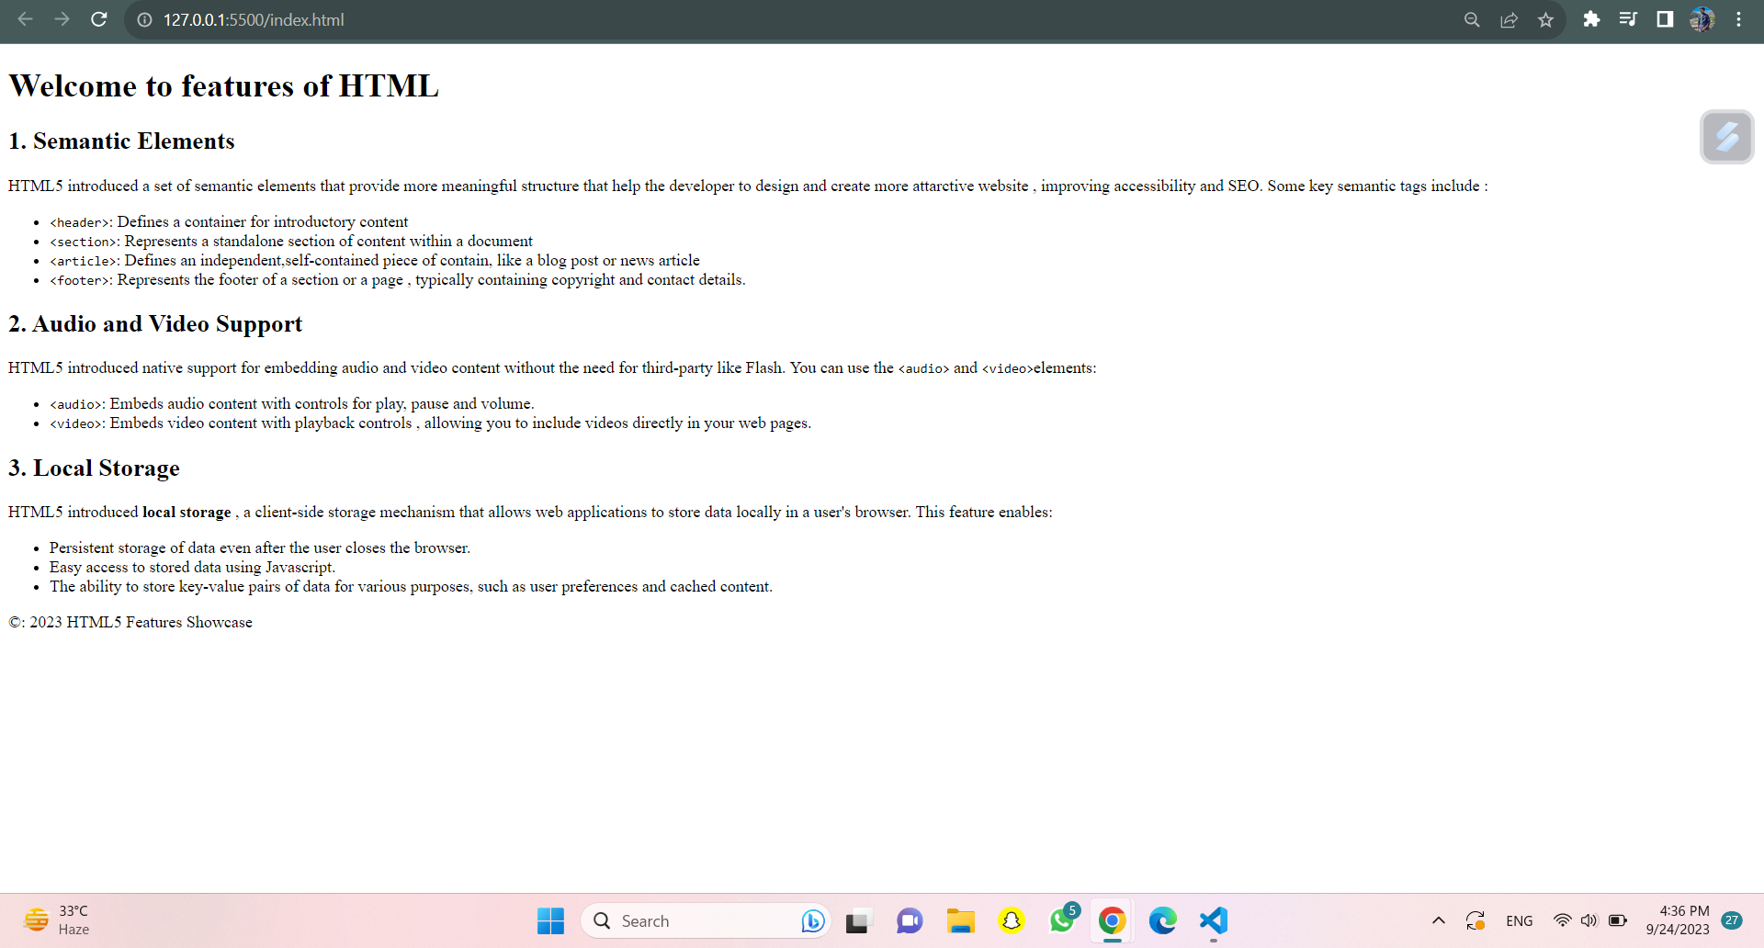

Ans.06

<!DOCTYPE html>

<html lang="en">

<head>

<meta charset="UTF-8">

<meta name="viewport" content="width=device-width, initial-scale=1.0">

<title>Table</title>

<style>

body {

font-family: Arial, sans-serif;

margin: 20px;

}

table {

border-collapse: collapse;

width: 80%;

margin: 20px auto;

}

th, td {

border: 1px solid #ccc;

padding: 10px;

text-align: left;

}

th {

background-color: #f0f0f0;

}

</style>

</head>

<body>

<h1>Difference between HTML and HTML5</h1>

<table>

<thead>

<tr>

<th>HTML</th>

<th>HTML5</th>

</tr>

</thead>

<tbody>

<tr>

<td>HTML stands for Hypertext Markup Language </td>

<td>HTML5 stands for Hypertext Markup Language 5</td>

</tr>

<tr>

<td>HTML4 was the previous version of HTML.</td>

<td>HTML5 is the latest version of HTML.</td>

</tr>

<tr>

<td>HTML4 had limited support for multimedia and graphics.</td>

<td>HTML5 provides native support for audio and video elements.</td>

</tr>

<tr>

<td>HTML4 did not have built-in form validation.</td>

<td>HTML5 introduces client-side form validation and new input types like email and date. </td>

</tr>

<tr>

<td>HTML4 required plugins like Flash for interactive web content. </td>

<td>HTML5 supports canvas and SVG for native graphics and animations. </td>

</tr>

</tbody>

</table>

</body>

</html>

Output:

